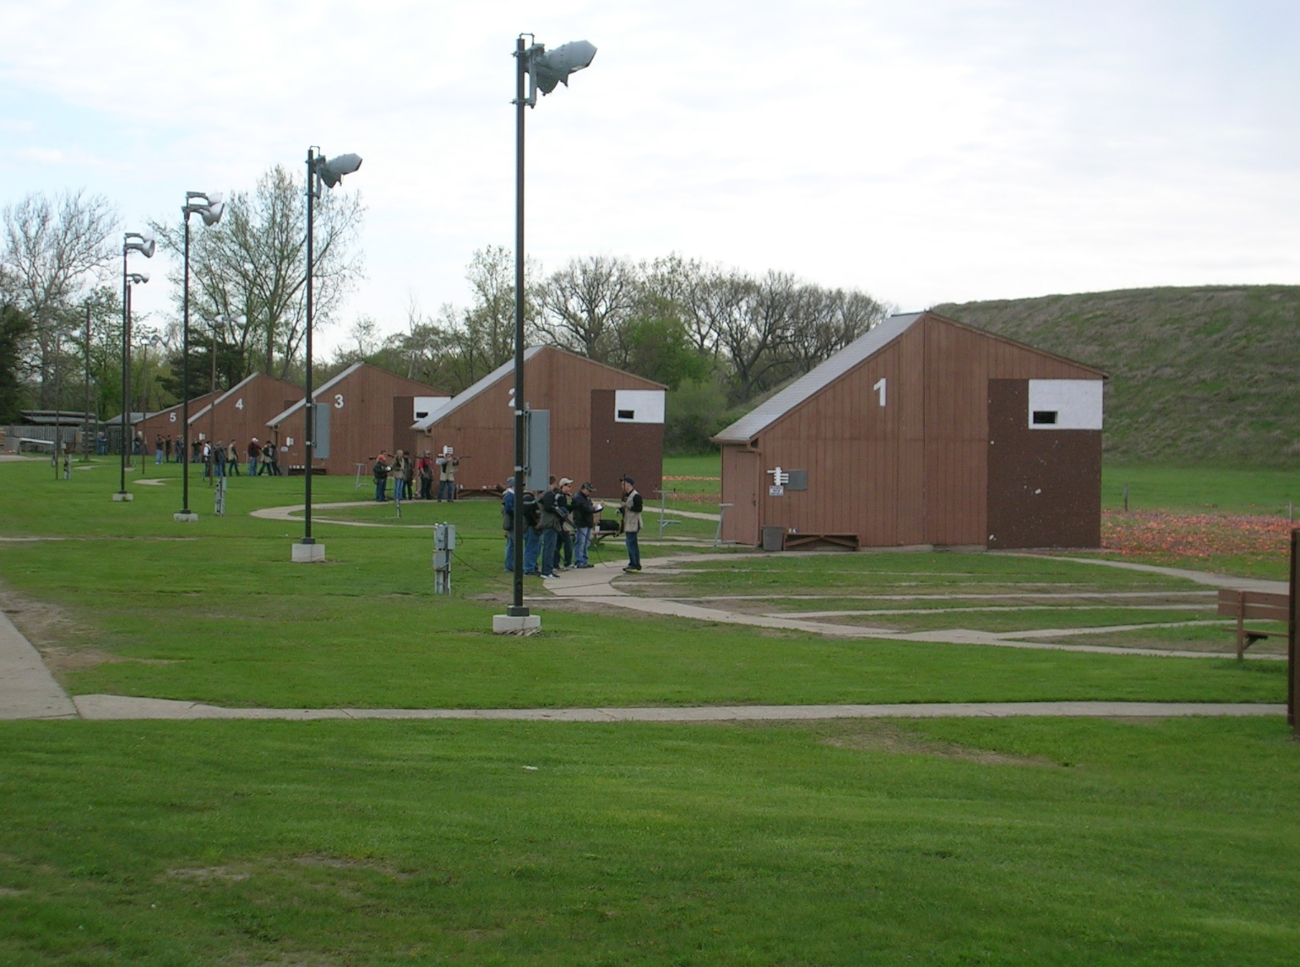
BASIC SHOTGUN CLASS
COURSE COVERAGE
SAFETY/GUN FAILURES/TRANSPORTING/STORAGE
EYE DOMINANCE
PARTS OF A SHOTGUN
ACTION TYPES AND OPERATION
CHOKES/SHOT PATTERNS
AMMUNITION/SHOTGUN GAUGE SIZES
SHOOTING POSITION/ GUN FIT
MOVEMENT ON TARGET
SKEET/TRAP/5 STAND FUNDAMENTALS

WHERE DETROIT SPORTSMEN’S CONGRESS SHOTGUN RANGE BUILDING
WHEN SUNDAY, JULY 21
TIME 8 a.m.—4 p.m.
REGISTRATION AT THE PRO-SHOP DURING OPEN HOURS
COST: $60
REGISTRATION OPEN JULY 1ST
REGISTRATION INCLUDES – INSTRUCTION, A ROUND OF SKEET, TRAP, 5 STAND AND LUNCH
BRING YOUR SHOTGUN (SOME SHOTGUNS AVAILABLE)
AMMUNITION CAN BE PURCHASED IN THE PRO-SHOP OR BRING YOUR OWN

